Name : Cheruvathoor Abin Anto

Roll No : TIT2425008

Practical No: 1: Pivot Table and Chart

1. Pivot Table
2. Example 1

* Insert Pivot Table
* To start off, select any cell in the data and click Pivot Table on the Insert tab of the ribbon:

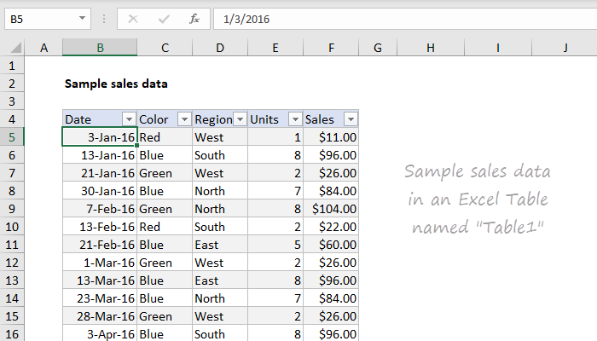

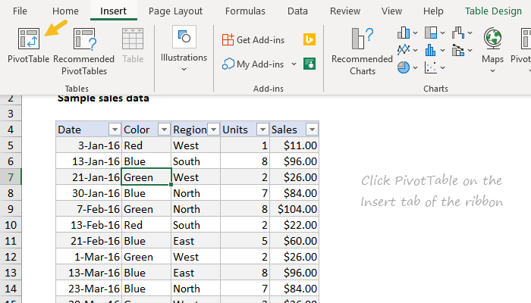

* Override the default location and enter H4 to place the pivot table on the current worksheet:

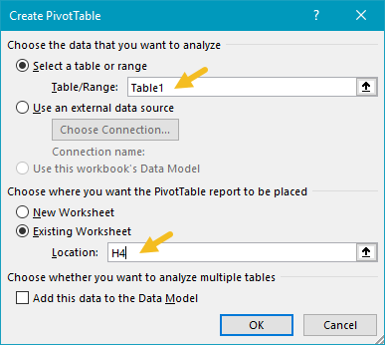

* Click OK, and Excel builds an empty pivot table starting in cell H4.

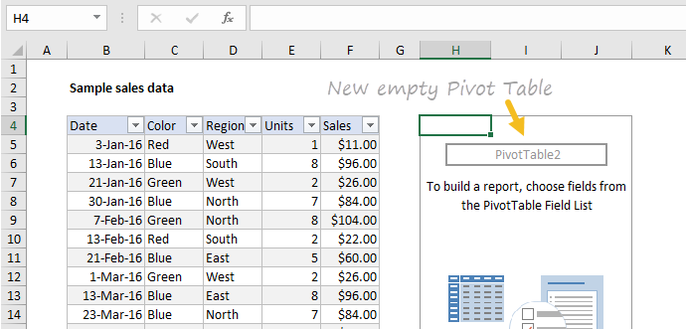

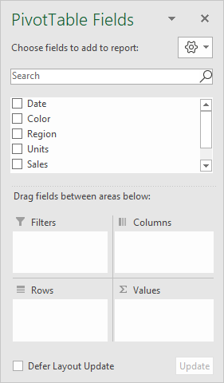

* Adding Fields
* To Drag the Sales field to the Values area

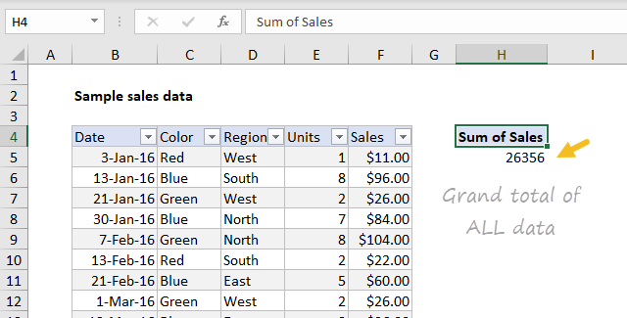

* Drag the Color field to the Rows area.

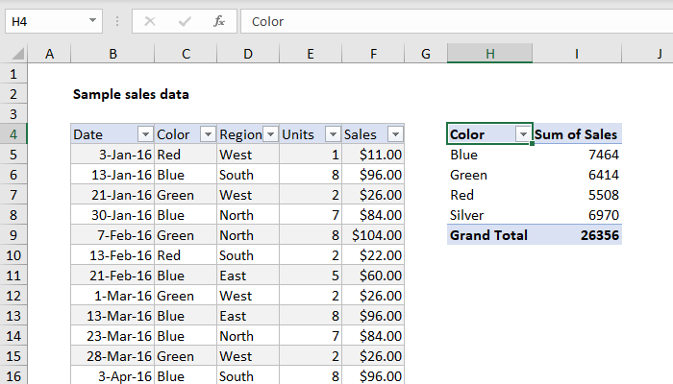

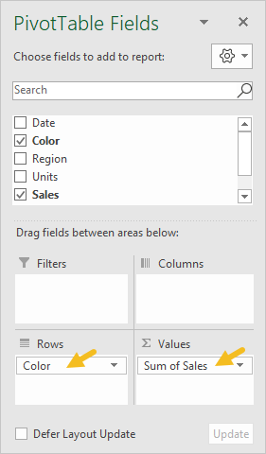

* Numbering Formatting
* Right-click any Sales number and choose Number Format:

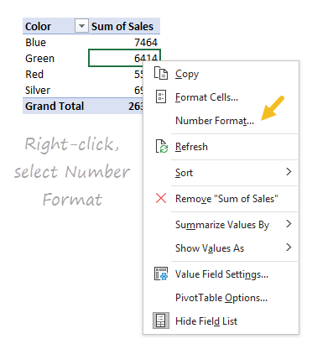

* Apply Currency formatting with zero decimal places, the click OK:

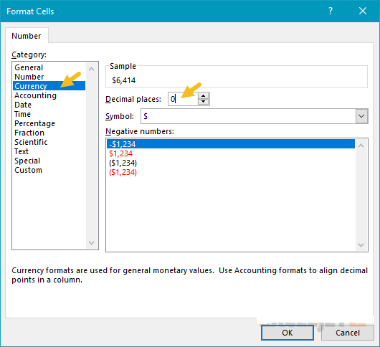

In the resulting pivot table, all sales values have Currency format applied:

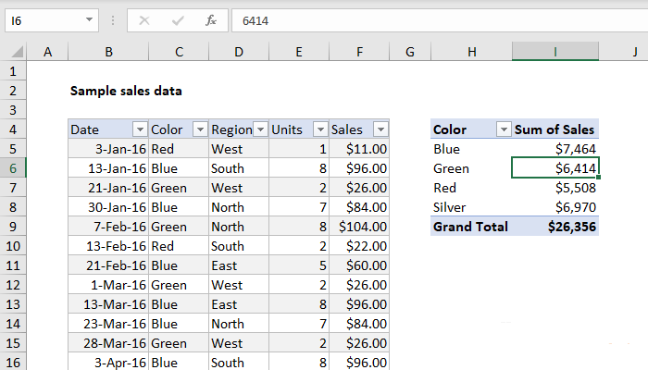

Currency format will continue to be applied to Sales values, even when the pivot table is reconfigured, or new data is added.

* Sorting By Value
* Right-click any Sales value and choose Sort > Largest to Smallest.

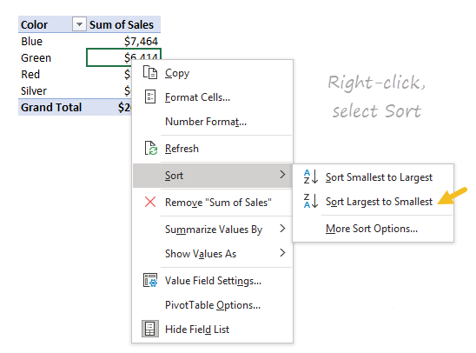

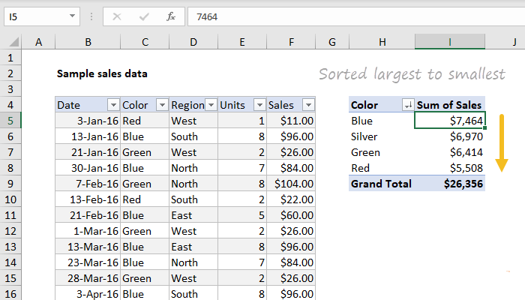

* Refresh Data

Pivot table data needs to be "refreshed" in order to bring in updates. To reinforce how this works, we'll make a big change to the source data and watch it flow into the pivot table.

* Select cell F5 and change $11.00 to $2000.
* Right-click anywhere in the pivot table and select "Refresh".

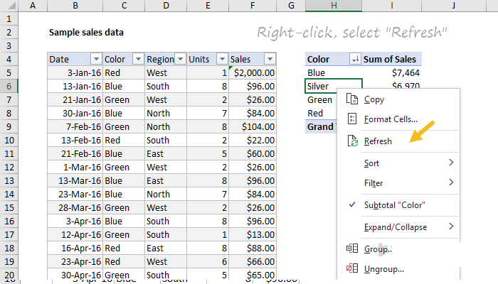

Notice "Red" is now the top selling color, and automatically moves to the top:

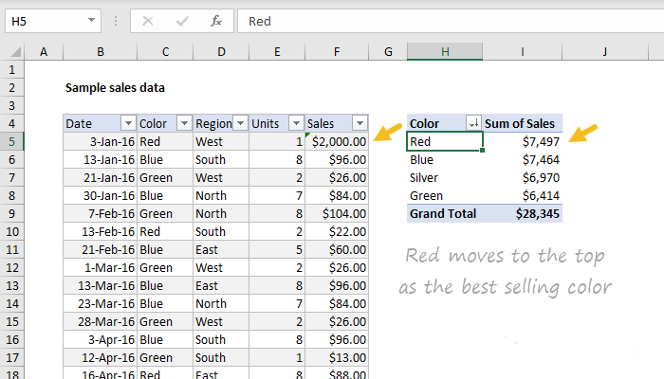

* Change F5 back to $11.00 and refresh the pivot again.
* Second Value Field

You can add more than one field as a Value field.

* Drag Units to the Value area to see Sales and Units together:

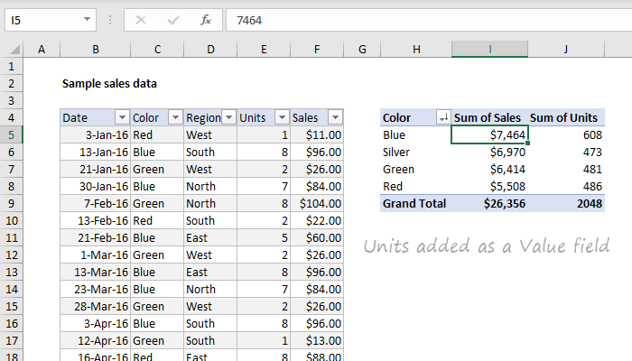

* Percent Of Total

There are different ways to display values. One option is to show values as a percent of total. If you want to display the same field in different ways, add the field twice.

* Remove the Units from the Values area
* Add the Sales field (again) to the Values area.
* Right-click the second instance and choose "% of grand total":

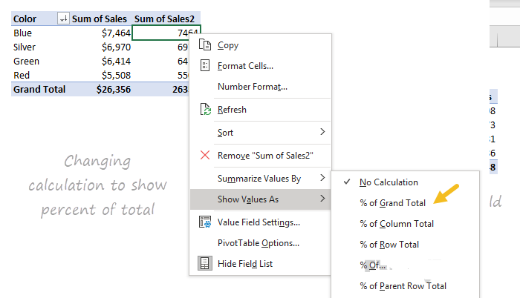

The result is a breakdown by color along with a percent of total:

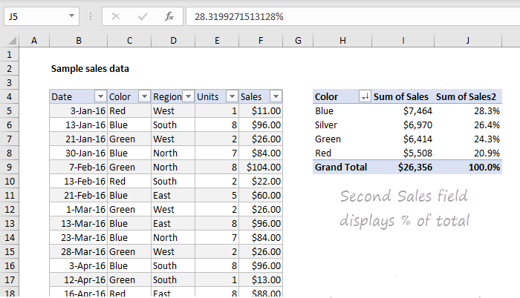

Here is the Fields pane at this point:

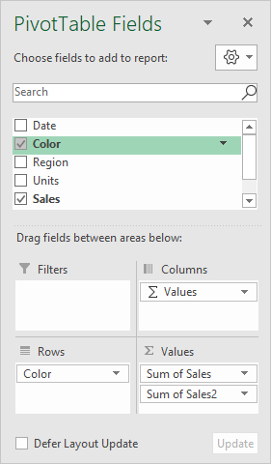

* Group By Data

Pivot tables have a special feature to group dates into units like years, months, and quarters. This grouping can be customized.

* Remove the second Sales field (Sales2).
* Drag the Date field to the Columns area.
* Right-click a date in the header area and choose "Group":

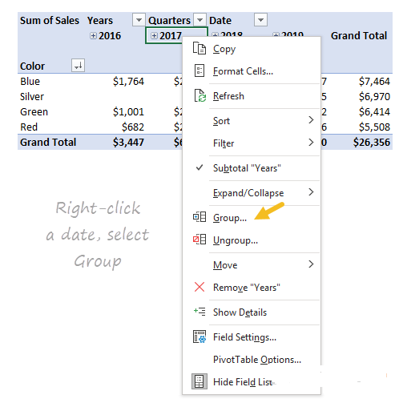

* When the Group window appears, group by Years only (deselect Months and Quarters):

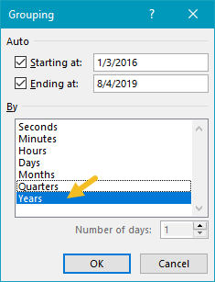

We now have a pivot table that groups sales by color and year:

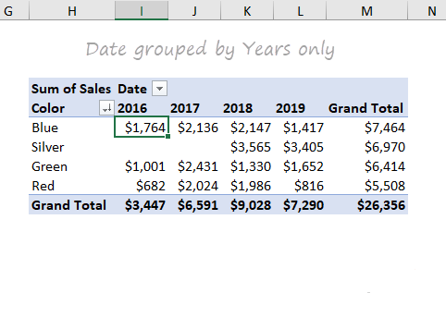

Notice there are no sales of Silver in 2016 and 2017.

Here is the Fields pane at this point:

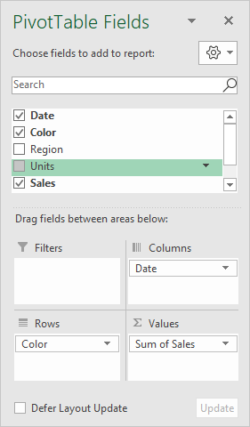

* Two-Way Point

Pivot tables can plot data in various two-dimensional arrangements.

* Drag the Date field out of the columns area
* Drag Region into the Columns area.

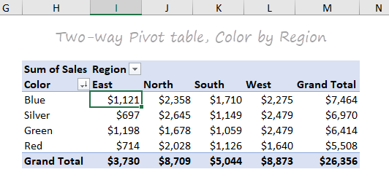

* Swap Region and Color (i.e. drag Region to the Rows area and Color to the Columns area).

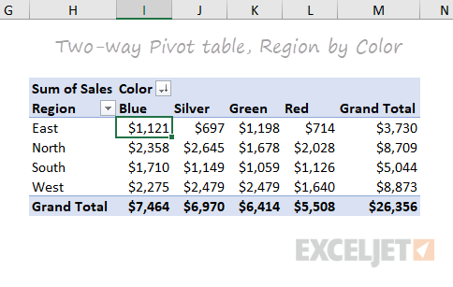

Again notice total sales ($26,356) is the same in *all pivot tables above*.

Each table presents a different view of the *same data*, so they all sum to the *same total*.

1. Example 2

* Insert Pivot Table
* Drag Fields
* Product field to the Rows area.
* Amount field to the Values area.
* Country field to the Filters area.

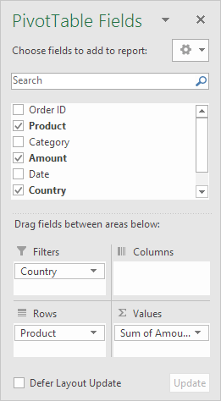

Below you can find the pivot table. Bananas are our main export product. That's how easy pivot tables can be!

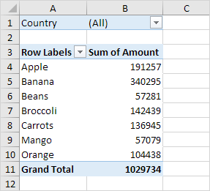

* Sort

To get Banana at the top of the list, sort the pivot table.

* Click any cell inside the Sum of Amount column.
* Right click and click on Sort, Sort Largest to Smallest.

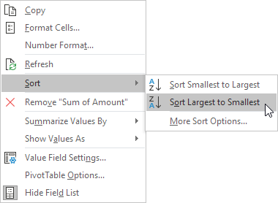

Result

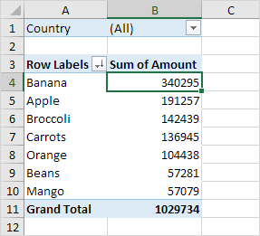

* Filter

Because we added the Country field to the Filters area, we can filter this pivot table by Country. For example, which products do we export the most to France?

* Click the filter drop-down and select France.

Result. Apples are our main export product to France.

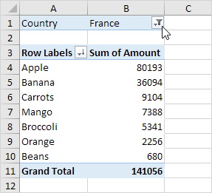

* Change Summary Calculation

By default, Excel summarizes your data by either summing or counting the items. To change the type of calculation that you want to use, execute the following steps.

* Click any cell inside the Sum of Amount column.
* Right click and click on Value Field Settings.

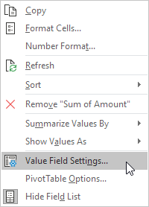

* Choose the type of calculation you want to use. For example, click Count.

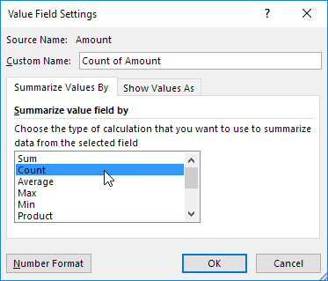

* Click OK.

Result 16 out of the 28 orders to France were 'Apple' orders.

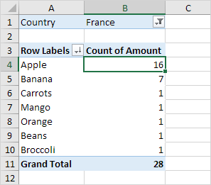

* Two – Dimensional Pivot Table

If you drag a field to the Rows area and Columns area, you can create a two-dimensional pivot table. First, [insert a pivot table](https://www.excel-easy.com/data-analysis/pivot-tables.html#insert-pivot-table).

Next, to get the total amount exported to each country, of each product, drag the following fields to the different areas.

* Country field to the Rows area.
* Product field to the Columns area.
* Amount field to the Values area.
* Category field to the Filters area.

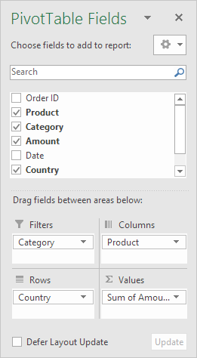

Below you can find the two-dimensional pivot table.

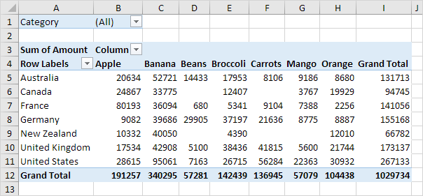

1. Pivot Chart

A pivot chart is the visual representation of a pivot table in Excel. Pivot charts and pivot tables are connected with each other.



* Insert Pivot Chart

To insert a pivot chart, execute the following steps.

* Click any cell inside the pivot table.
* On the Analyze tab, in the Tools group, click PivotChart.

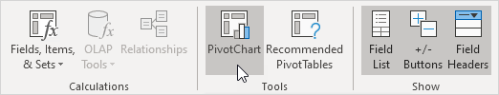

The Insert Chart dialog box appears.

* Click OK.

Below you can find the pivot chart. This pivot chart will amaze and impress your boss.

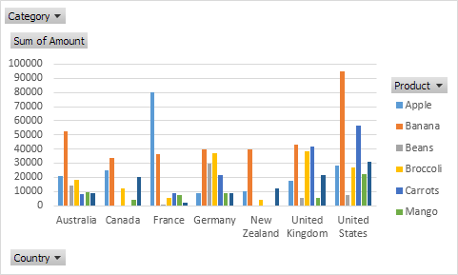

* Filter Pivot Chart

To filter this pivot chart, execute the following steps.

* Use the standard filters (triangles next to Product and Country). For example, use the Country filter to only show the total amount of each product exported to the United States.

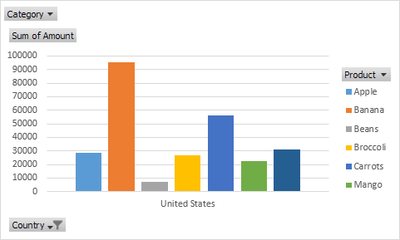

* Remove the Country filter.
* Because we added the Category field to the Filters area, we can filter this pivot chart (and pivot table) by Category. For example, use the Category filter to only show the vegetables exported to each country.

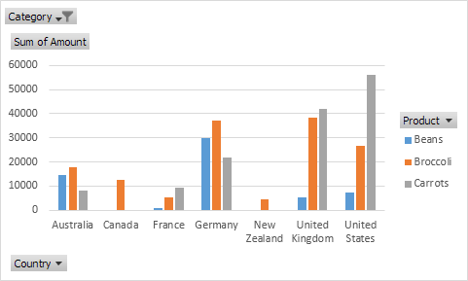

* Change Pivot Chart Type

You can change to a different type of pivot chart at any time.

* Select the chart.
* On the Design tab, in the Type group, click Change Chart Type.

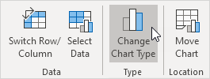

* Choose Pie.

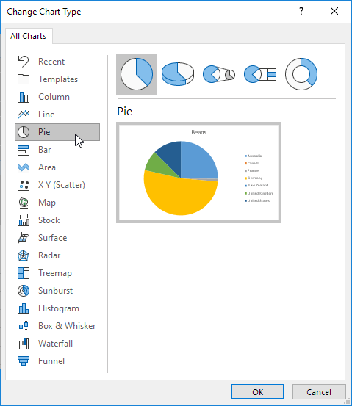

* Click OK.

Result:

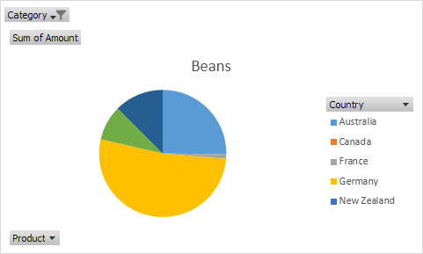

Practical No: 2: What If Analysis

1. **What-If Analysis** is the process of changing the values in cells to see how those changes will affect the outcome of formulas on the worksheet.

| **Concert Budget** |  |
| --- | --- |
|  |  |
| **Costs** |  |
| Venue : |  |
| #Seats | **300** |
|  |  |
| Artist Payment | **4,000** |
| Venue Rent | **500** |
| Amplification | **300** |
| Lighting | **250** |
| Ticket | **200** |
| Security | **150** |
| Insurance | **100** |
|  | **5,500** |
|  |  |
| **Revenues** |  |
|  |  |
| Price/Ticket | **30** |
|  |  |
| Ticket Sales | **9,000** |
| Merchandising | **1,500** |
| Food & Beverage | **4,500** |
| Tot. Revenue | **15,000** |
|  |  |
| **Profit or Loss** | **9,500** |
|  |  |

1. Insert Scenario Manager

So the question is what changes have to be done to get maximum profit

Go to Data Menu and then go to What if Analysis, in that select Scenario Manager

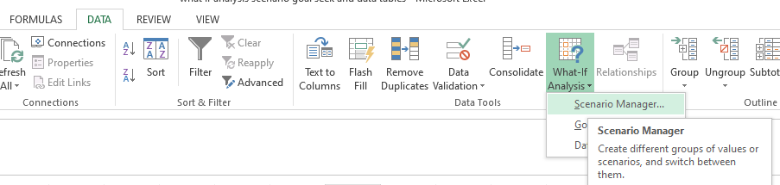

In the window that opens click on Add.

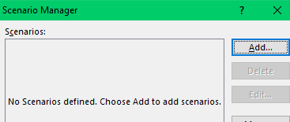

Make the below changes and click on OK.

In Changing cells: add B5, B7:B13,B18

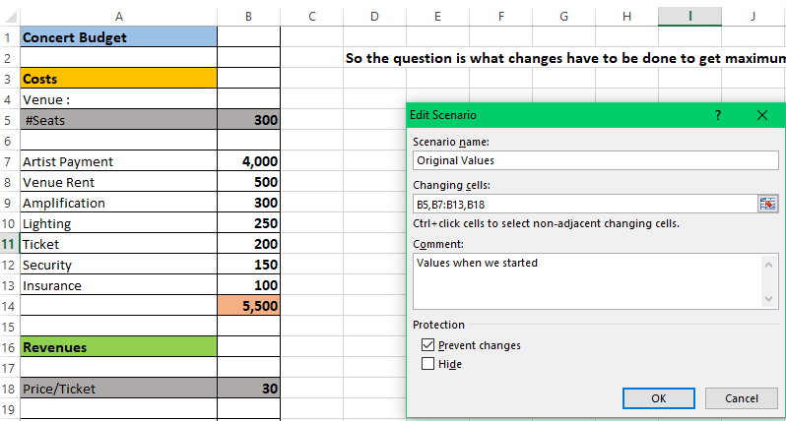

The below window pops up

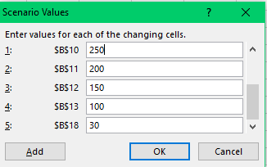

This is just to see the original values. Click OK

In the window that appears click Add

Give a new Scenario Name as Medium Revenue

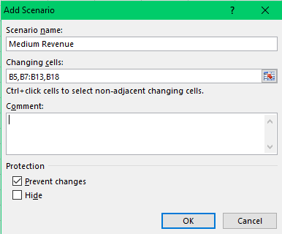

Click OK.

Then add the new values which is inside the red rectangle in the cell names in the Scenario Values window and click OK



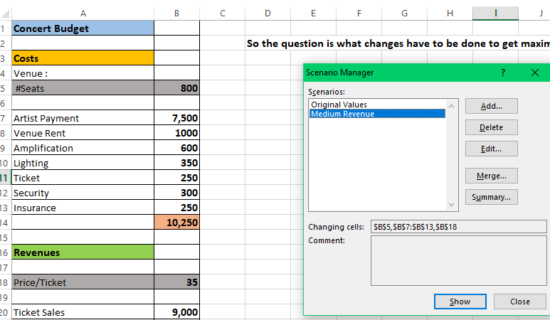

In the window that appearsclickAdd

Give a new Scenario Name as Large Revenue

Click OK.

Then add the new values which is inside the red rectangle in the cell names in the Scenario Values window and click OK

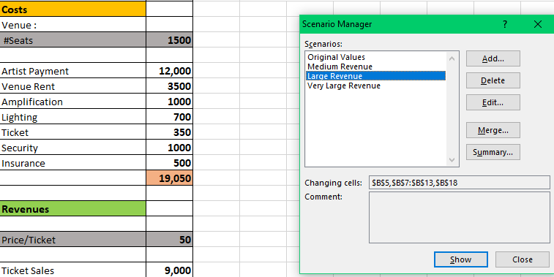

In the window that appearsclickAdd

Give a new Scenario Name as Very Large Revenue

Click OK.

Then add the new values which is inside the red rectangle in the cell names in the Scenario Values window and click OK

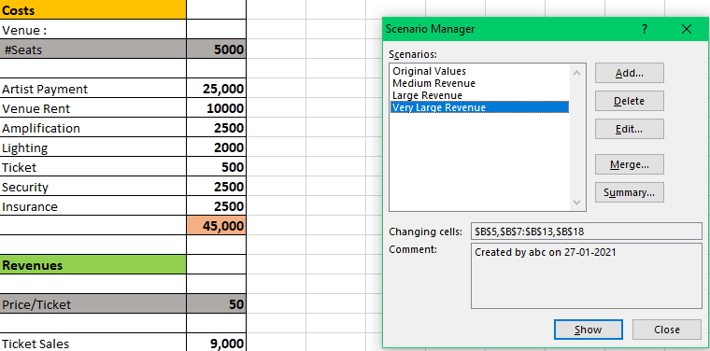

To see the comparison click onSummary

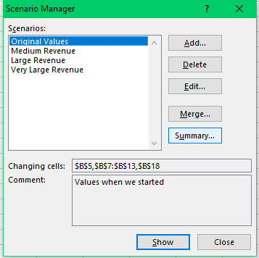

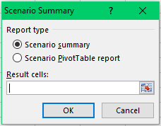

Above click on scenario summary and click OK

You can compare the Profit by adding B25 in the Result cells as seen below

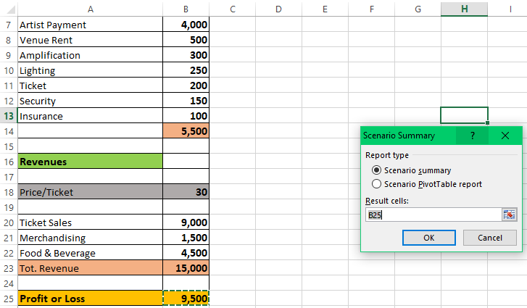

So now the comparison can be seen as below in a different sheet

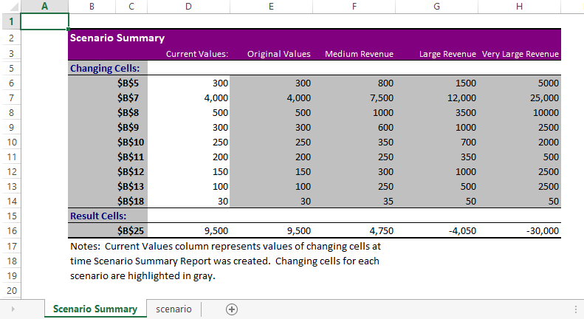

In the table above you can now give the actual Name for the Rows as seen below:

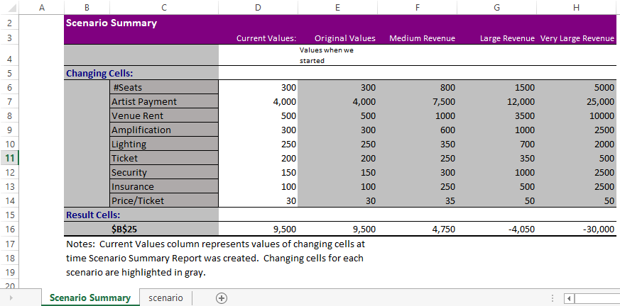

1. Insert Goal Seek
2. Example 1:

Problem: It is a typical business situation - you have the sales figures for the first 3 quarters and you want to know how much sales you have to make in the last quarter to achieve the target net profit for the year, say, 100000.

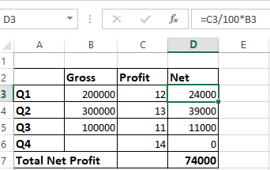

Solution: With the source data organized like shown in the screenshot above, set up the following parameters for the Goal Seek function:

* Set cell - the formula that calculates the total net profit (D7).
* To value - the formula result you are looking for (100000).
* By changing cell - the cell to contain the gross revenue for quarter 4 (B6).

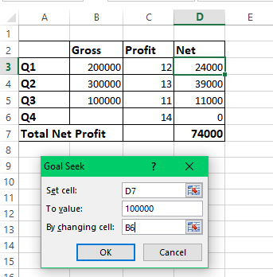

Result: The Goal Seek analysis shows that in order to obtain 100000 annual net profit, your fourth-quarter revenue must be 185714.

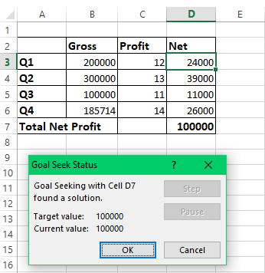

1. Example 2: Determine the exam passing score

Problem: At the end of the course, a student takes 3 exams. The passing score is 70%. All the exams have the same weight, so the overall score is calculated by averaging the 3 scores. The student has already taken 2 out of 3 exams. The question is: What score does the student need to get for the third exam to pass the entire course?

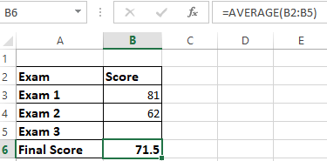

Solution**:** Let's do Goal Seek to determine the minimum score on exam 3:

* Set cell - the formula that averages the scores of the 3 exams (B6).
* To value - the passing score (70%).
* By changing cell - the 3rd exam score (B5).

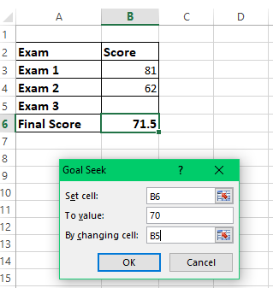

Result**:** In order get the desired overall score, the student must achieve a minimum of 67% on the last exam:

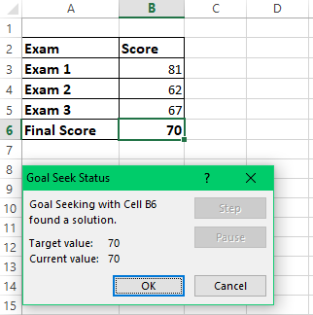

1. Example 3: What-If Analysis of the Election

Problem: You are running for some elected position where a two-thirds majority (66.67% of votes) is required to win the election. Assuming there are 200 total voting members, how many votes do you have to secure? Currently, you have 98 votes, which is quite good but not sufficient because it only makes 49% of the total voters:

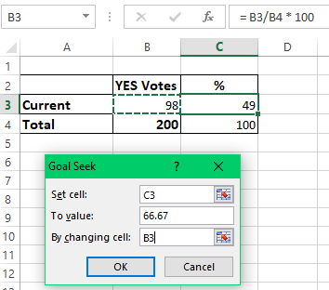

Solution: Use Goal Seek to find out the minimum number of "Yes" votes you need to get:

* Set cell - the formula that calculates the percentage of the current "Yes" votes (C2).
* To value - the required percentage of "Yes" votes (66.67%).
* By changing cell - the number of "Yes" votes (B2).



Result: What-If analysis with Goal Seek shows that to achieve the two-thirds mark or 66.67%, you need 133 "Yes" votes:

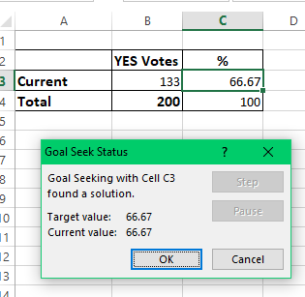

Practical No: 3: Chapter 2

1. Create Data Frame in Python using educ_figdp_1_Data.csv data set and there by demonstrate the following operations on the Data Set : Reading Data into a Data frame, Filtering Data, Filtering missing Data, Manipulating Data, Sorting, Grouping Data, Rearranging Data, Ranking Data, Plotting Data.

* The Data Frame Data Structure

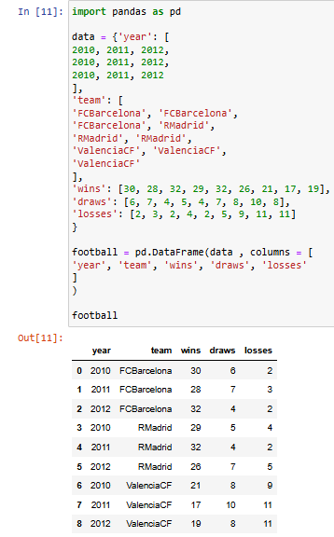

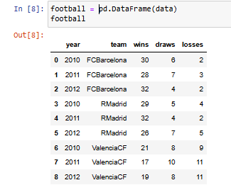

* Reading csv file

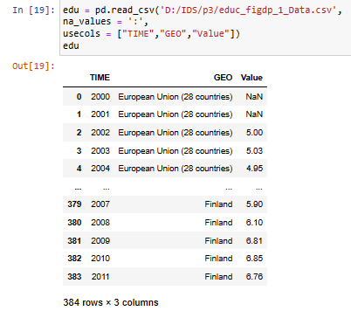

* to know the data type of a column, type the following

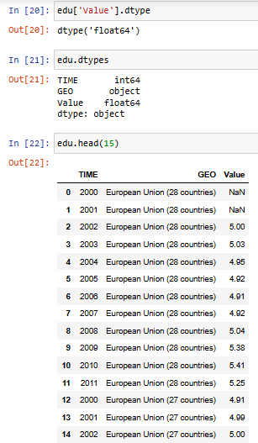

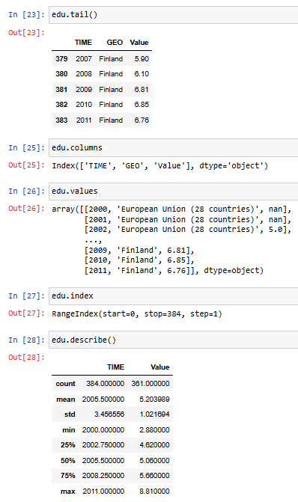

* SelectingData

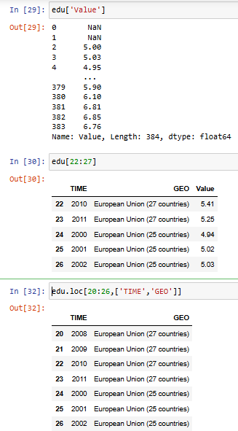



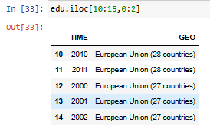

* Filtering Data

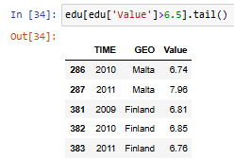

* Filtering missing Data

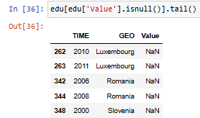

* Manipulating Data

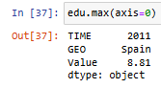

* missing values not considered



* missing values considered that is NaN



* dividing value column by 100

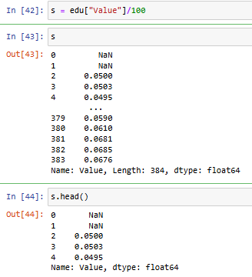

* Square root, lambda, Creating new Column (ValueNorm), drop new Column

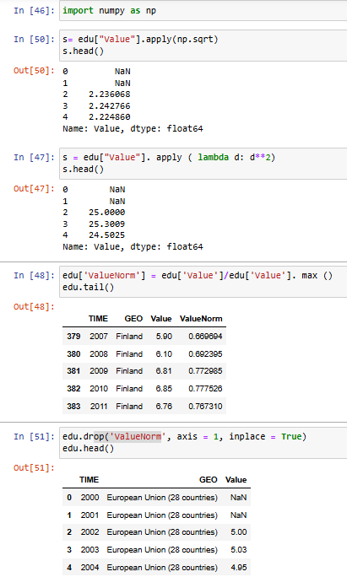

* Creating & Modifying Data Frame (inplace = False)

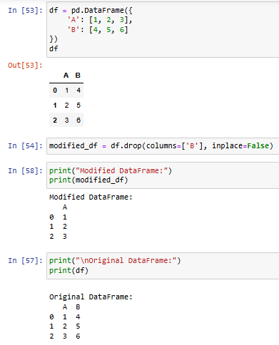

* Creating & Modifying Data Frame (inplace = True)

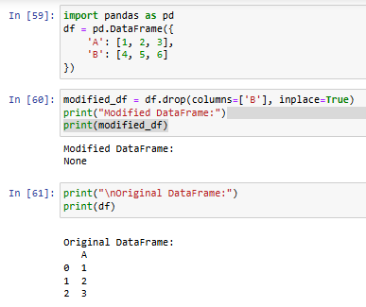

* Append, Max, Drop NA, Fill NA

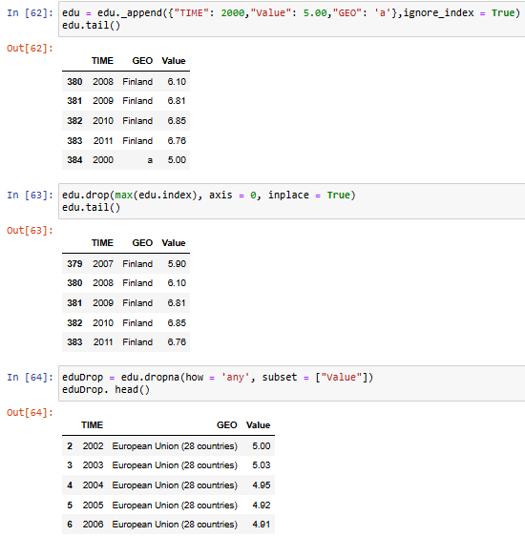

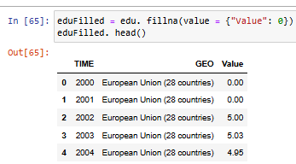

* Sorting

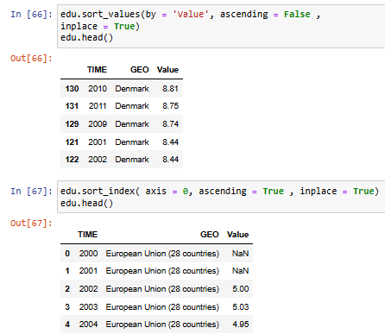

* Grouping Data

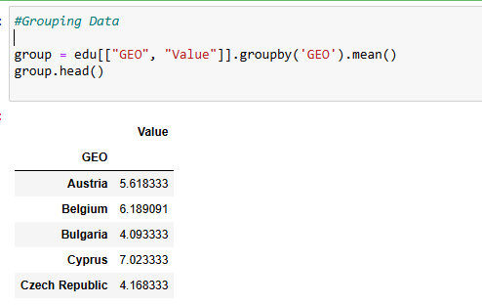

* Rearranging Data

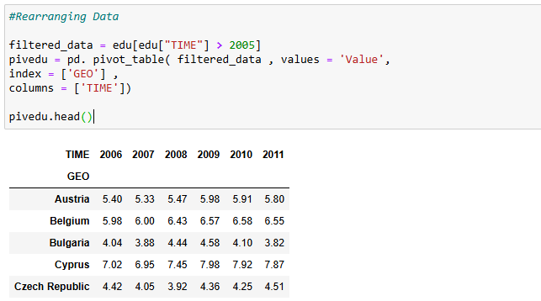

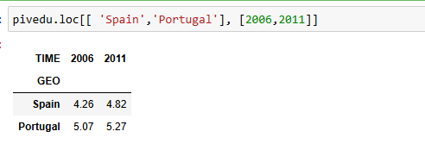

* Ranking Data

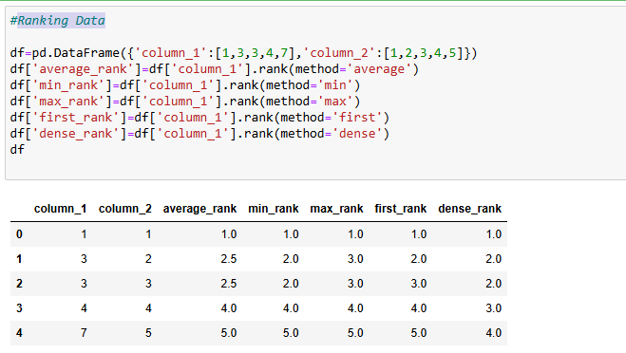

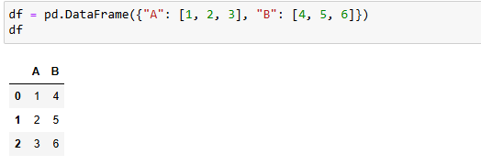

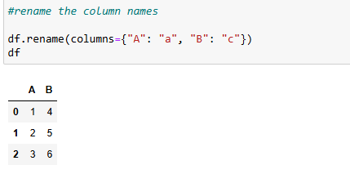

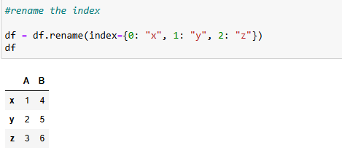

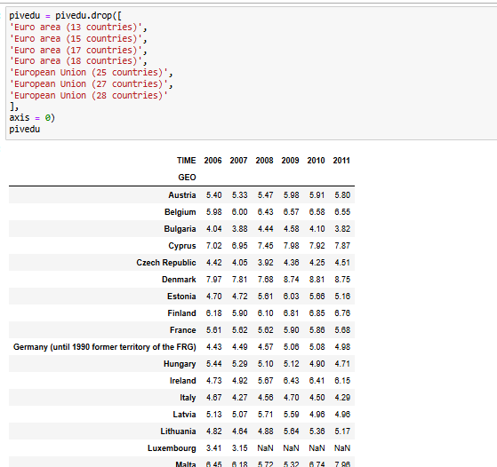

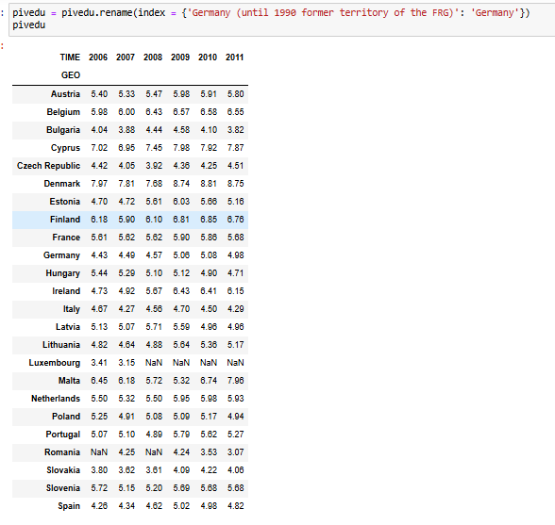

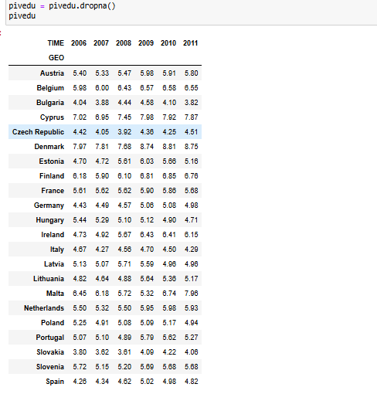

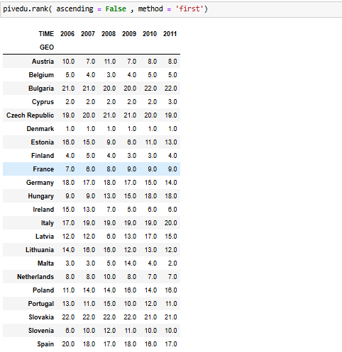

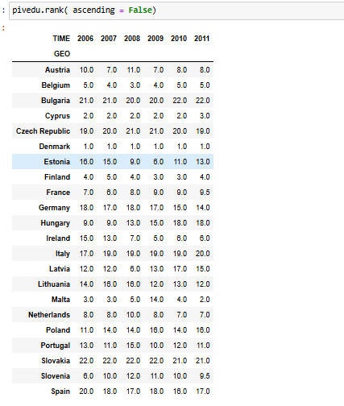

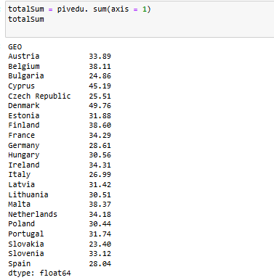

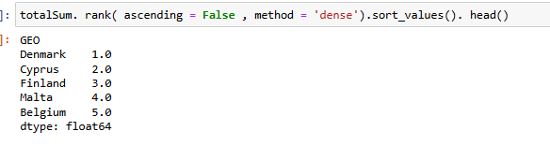

* Plotting

